University Of Engineering and Technology, Lahore
Computer Engineering Department

Course Name: Programming Fundamentals | Course Code: CMPE-112L
Assignment Type:Lab Tasks | Dated: 20-04-2026
Semester: 1st | Session: Spring
Lab/Project/Assignment #: 6 | CLOs to be covered: CLO 3
Lab Title: Local And Global Variables | Teacher Name: Hafiz Muhammad Mubashar
Lab Evaluation:

CLO1 | Apply appropriate programming techniques to create executable programs to solve well defined problems
 | Level1 | Level2 | Level3 | Level4 | Level5 | Level6
(5)
Total |  |  |  |  |  | /5
Rubrics for Current Lab Evaluation
Scale | Marks | Level | Rubric
Excellent | 5 | L1 | Submitted all lab tasks, BONUS task, have good understanding.
Very Good | 4 | L2 | Submitted the lab tasks but have good understanding
Good | 3 | L3 | Submitted the lab tasks but have weak understanding.
Basic | 2 | L4 | Submitted the lab tasks but have no understanding.
Barely Acceptable | 1 | L5 | Submitted only one lab task.
Not Acceptable | 0 | L6 | Did not attempt
LAB No 6
Lab Goals/Objectives:
To understand local and global variables in Python and their use in functions.
Equipment Required:
Computer or Laptop, Python 3.x, PyCharm or VS Code.
Theory:
Local variables are created inside functions, while global variables are declared outside functions and can be used throughout the program.

Lab Work:
Task 1: Display a local variable inside a function.
Result:
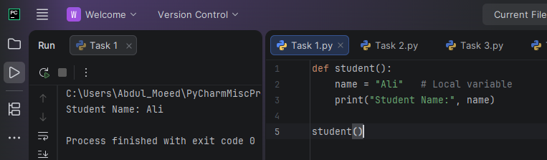
Task 2: Use a global variable inside a function.
Result:
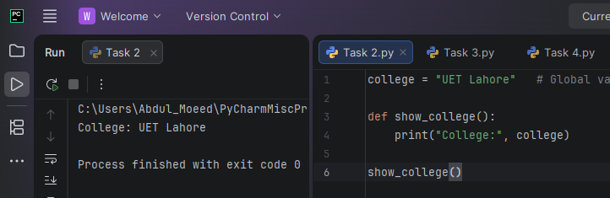
Task 3: Display multiple local variables.
Result:
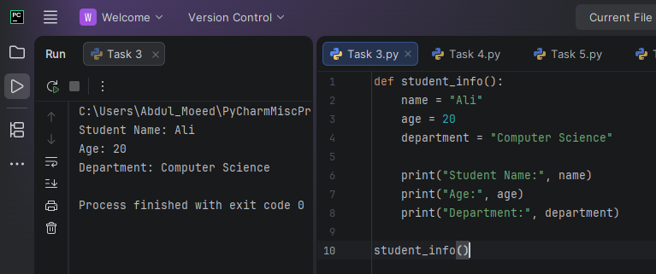

Task 4: Access one global variable from multiple functions.
Result:
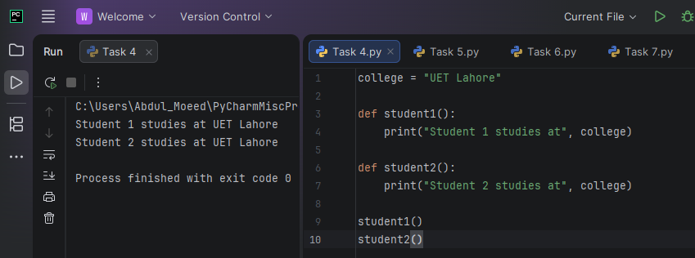
Task 5: Compare local and global variables.
Result: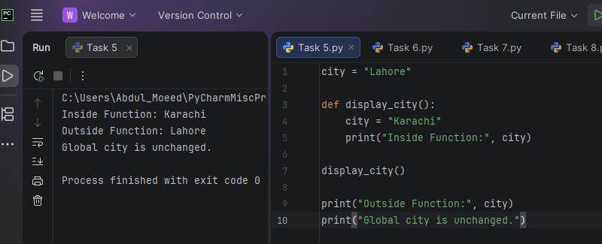
Task 6: Modify a global variable using the global keyword.
Result:
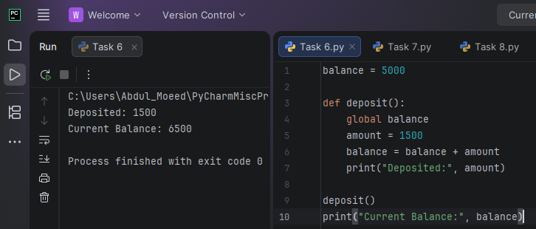
Task 7: Use local variables in a calculator function.
Result:
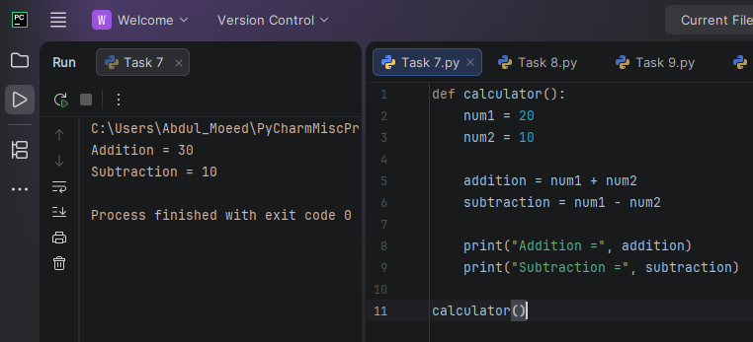
Task 8: Use a global variable with multiple functions.
Result:
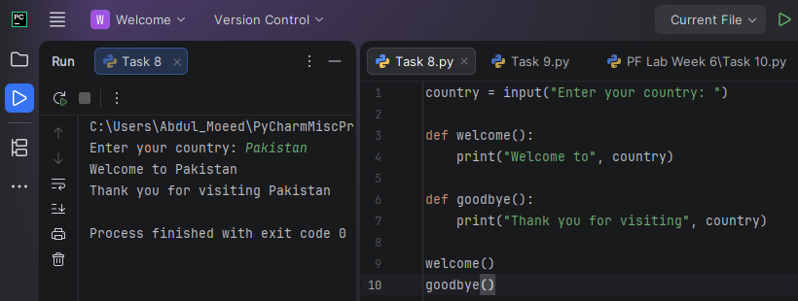
Task 9: Show the difference between local and global marks.
Result:
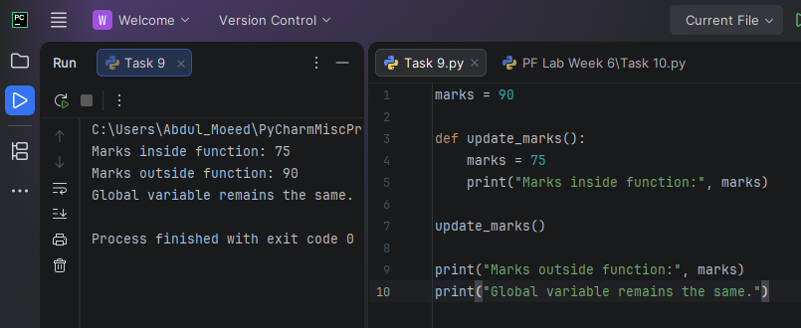

Task 10: Use one global variable in different functions.
Result:
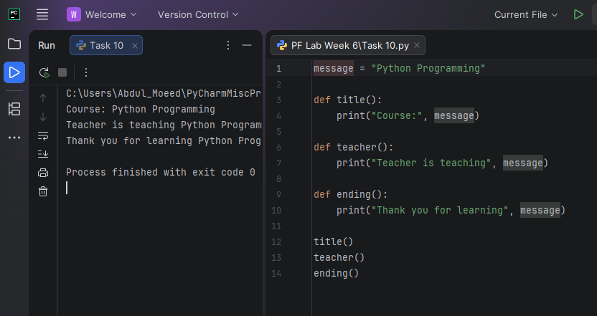

Conclusion:
The lab improved understanding of local and global variables and their use in Python functions.

